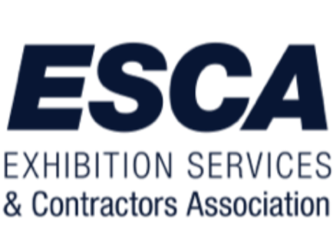

ESCA Behind The Scenes
Brought to you by the ESCA Education Committee

About the Course
Educating the personnel that will be working in your facility, on your show floor, and with your customers is a priority that results in a better experience, a safer environment, and a stronger industry. A broader-based knowledge of how events are orchestrated will help your exhibitors, contractors, and suppliers form a more robust understanding of where they fit in the larger picture and how they could more fluidly move about in that environment. This course is meant to help achieve that understanding. The attendees can be anyone from 20-year veterans who have likely seen it all to new members of our industry that are soaking it all in.
The whole experience is a hands-on learning experience, with the takeaway hopefully being a few more tools in each attendee’s tool belt, with an overall better experience for the venue and a stronger industry. Every obstacle we can remove, every bump in the road we can smooth, will benefit every member of our trade show family.

About the Training Day
ESCA customizes each program to meet the requests of the individual facility. We look for the partnership of the Official Service Contractors, Suppliers, and Local Unions to ensure the event's success. In advance of the program, we will explore the needs of the local city to create a program that best meets those needs.
Typically we will begin by educating the attendees about your city and your facility. A brief overview for those fresh to the venue and an update on what is new and upcoming for the veterans. We will then take a detailed tour of the show floor to see an event in action. This tour will touch on areas such as registration, entrances, labor desks, customer service areas, freight receiving, docks, marshaling yards, and empty storage. Moving about the show floor, we will explain how each area works as a cog in a very well-oiled machine. We will work to impart a greater understanding of how their role, and their organization, fit into the operation as a whole.

Cost
We strive to have this program presented at no cost to the attendees that are ESCA Members. For non-ESCA members, the cost is typically $25 per person. We will ask the facility to assist us with the cost of meeting rooms and any AV needs. There is no charge to the facility or the requesting member organization. The cost of this event is paid for in dividends by the benefit to the industry.
Please get in touch with Julie Kagy, ESCA Director of Operations, if you would like more information about this program. 773.418.1955 or julie@esca.org

