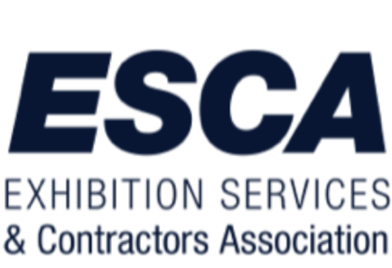

ESCA Customer Service Training Program
Brought to you by the ESCA Labor and Management Council

About the Course
As Trade Show Professionals, we consider ourselves the best, the fastest, and the most efficient, but this course does not begin or end with an emphasis on the “nuts and bolts” of your work as a Trade Show Professional. It doesn’t address how you can be more effective with your tools or how to improve your technical skills on the show floor. However, it addresses another skill set we often forget about.
Our skills as professionals should also include the interpersonal skills that our employers and end users observe. These skills, the ones that allow us to interact, react, build relationships with, and encourage future partnerships, are the ones we’ll discuss in this course.
Customer Service is not just a set of skills you pull out of your toolbox. It is a series of attitudes and behaviors that are learned and practiced. They affect not only our interaction with people in the workplace but also our interactions with every person we encounter.
Exercising “world-class” customer service skills will affect your professional and personal life. They can lead to more work opportunities and a more favorable work environment. They can lead to more fun, exciting, and enriching relationships for everyone involved.

About the Training Day
ESCA customizes each program to meet the requests of the individual city. We look for the partnership of the General Service Providers, Suppliers, and Local Unions to ensure the event's success. In advance of the program, we would explore the needs of the local city to create a program that best meets those needs. Whether it be City Ambassador training, Equipment Certifications, Safety Compliance, or any other needed training, we will work with your local partners to develop a day of training that ensures your already talented workforce leaves with a few new tools in their toolbox to be used on the tradeshow floor.

Cost
We strive to have this program presented at no cost to the attendees. In addition, we will work with you to get each portion of this day sponsored so that each attendee is further encouraged to attend. The ultimate result will be a better experience for exhibitors, attendees, show organizers, and the industry.
Please get in touch with Julie Kagy, esca director of operations, for more information about this program. 773.418.1955

